**Week 1 Submission(Supply chain Project)**

1. **Inventory Table**

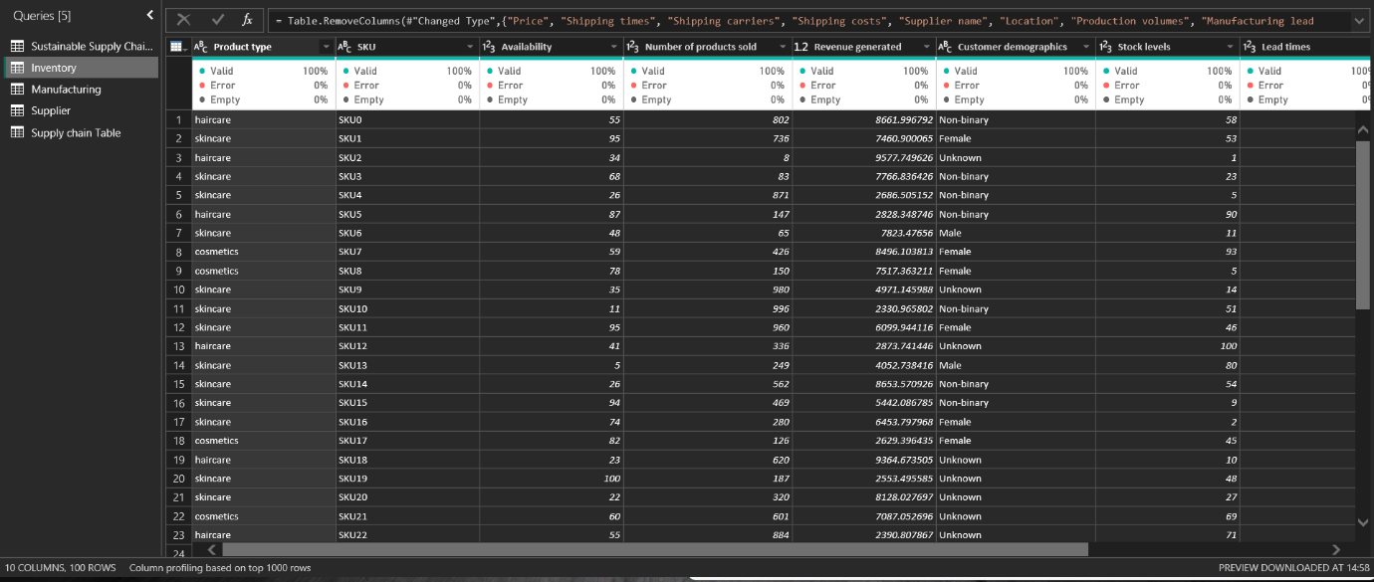

1. **Manufacturing Table**

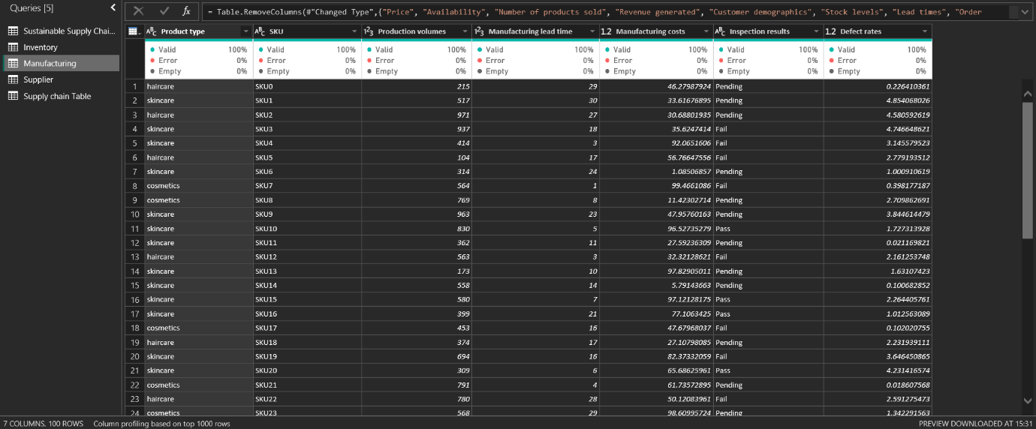

1. **Supplier Table**

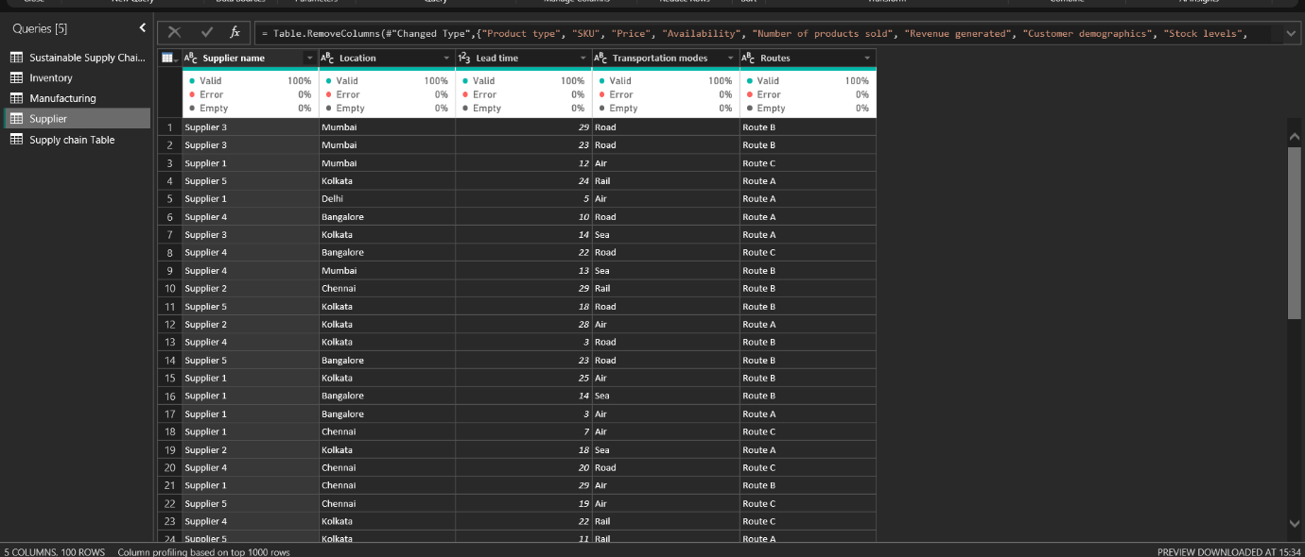

1. **Supply Chain Table**

